Learning Objective: To use an atlas to map a route.
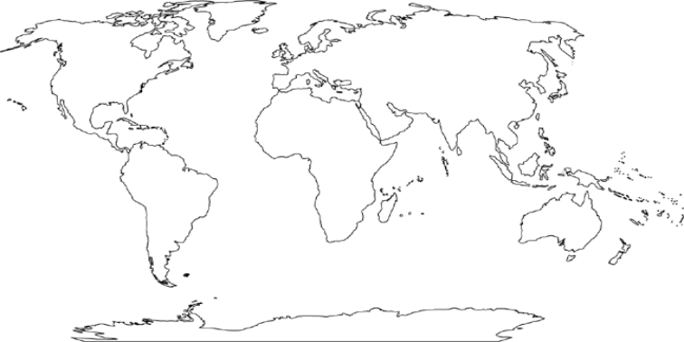
• Use an atlas and label the continents and the oceans of the World: Europe, Asia, North America, South America, Africa, Australasia, Antarctica, Pacific Ocean, Atlantic Ocean, Indian Ocean.
• Label and colour the UK and Brazil.
• Mark on the map the journey taken by A.R. Wallace from the UK to Brazil.

