**Lesson Overview**

**Research Injustice in Science**

| **AOLE: Science and Technology** | | |
| --- | --- | --- |
| **4 Purpose:**  **ethical, informed citizens** | | |
| **WM:** Being curious and searching for answers is essential to understanding and predicting phenomena. | | **DL:**  I can describe the impacts of science and technology, past and present, in my everyday life. |
| **LO:**  I can learn about the life and work of  Granville T Woods  Charles Drew  Henrietta Lacks  (Merlin Pryce) from Merthyr- as discussed in the Waterfront Museum talk  I can discuss how their work and their place in science was affected adversely by their colour. | | |
| **Intro:**  One of the key themes of this play is the fact that racism ran right through society, coming from the very top; that is to say, the “Establishment”. This included respected scientific bodies and universities, as well as hospitals and the armed forces. Each of the people below have had their rights violated as a result of who they were. Granville T Woods and Charles Drew did not gain the respect and advancements they deserved because of their race colour bar.  Is this fair?  What can you find out about each of these people? There are some starter links to help you below. | | |
| **Main:**  **Granville T Woods** was an American inventor who specialised in technology focusing on heat, electricity and communications. He was a self made man, who was always thinking of new ideas, solutions to practical problems and improvements to existing technology.  He was constantly challenged by other inventors as to the originality of his designs and went to court a number of times to prove that he had invented his products before others.  [GRANVILLE T WOODS (Inventor) - Black History Month](https://www.youtube.com/watch?v=rfQhfJXtc64)  [Amazing Inventors: Granville T. Woods and the Rollercoaster Revoloution | Kids Black History](https://www.youtube.com/watch?v=PV8AUyI5E2k)  (link to roller coaster design unit)  **Charles Drew** was an American Scientist who worked to prolong the life of donated blood by separating the blood cells from plasma. Because of the colour bar he was not allowed to donate his blood to the blood banks that he established during WW11.  <https://bloodcancer.org.uk/news/charles-r-drew-the-father-of-the-blood-bank/>  [Charles Richard Drew - Kids | Britannica Kids | Homework Help](https://kids.britannica.com/kids/article/Charles-Richard-Drew/544741)  [Charles R. Drew Facts for Kids](https://kids.kiddle.co/Charles_R._Drew)  **Henrietta Lacks** was an African American woman who died from cancer aged 31. Unknown to her family, some of the cancer cells were taken and have been used all around the world in research for cures for different types of cancer. Henrietta and her family were not asked if they wanted the cells to be harvested and so Henrietta’s family have been fighting to gain compensation for this invasion of her rights.  [The stolen legacy of Henrietta Lacks | Blood Cancer UK](https://bloodcancer.org.uk/news/the-stolen-legacy-of-henrietta-lacks/)  [Bringing Henrietta Lacks’ story to life in Bristol | The National Lottery Heritage Fund](https://www.heritagefund.org.uk/stories/bringing-henrietta-lacks-story-life-bristol)  [The Immortal Life of Henrietta Lacks (TV Movie 2017) - IMDb](https://www.imdb.com/title/tt5686132/)  **Merlin Pryce** was a Welshman from Merthyr who had been employed as a research assistant to Alexander Flemming. He was accidentally instrumental in the discovery of penicillin but was never offered or claimed the recognition that he should have received.  [BBC - Wales History: Dr Merlin Pryce and the discovery of penicillin](https://www.bbc.co.uk/blogs/waleshistory/2010/07/merlin_pryce_penicillin.html)  <https://pubmed.ncbi.nlm.nih.gov/12713008/>  choose one person to research  **Include:**   * Key personal details * An outline of their work * What injustice did they suffer * Has any reparation been offered? (recognition, compensation, righting of wrong) * What if anything should be done? | | |
| **Plenary:**  You can present your research in any way that suits you.  How do you feel about your findings?  Share with your classmates. | | |
| **Useful links:**  [Granville T. Woods | Coney Island History Project](https://www.coneyislandhistory.org/hall-of-fame/granville-t-woods#:~:text=For%20inventor%20Granville%20T.,coaster%20called%20the%20Figure%20Eight).  **Links to other units:**  Resilience ( HWB) | | |

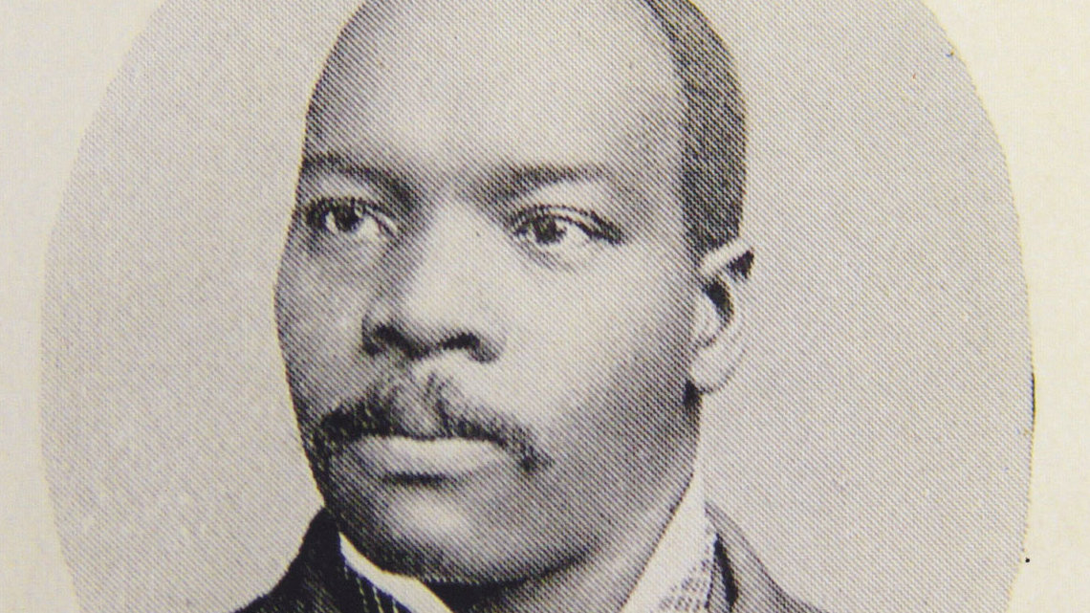

Granville T Woods

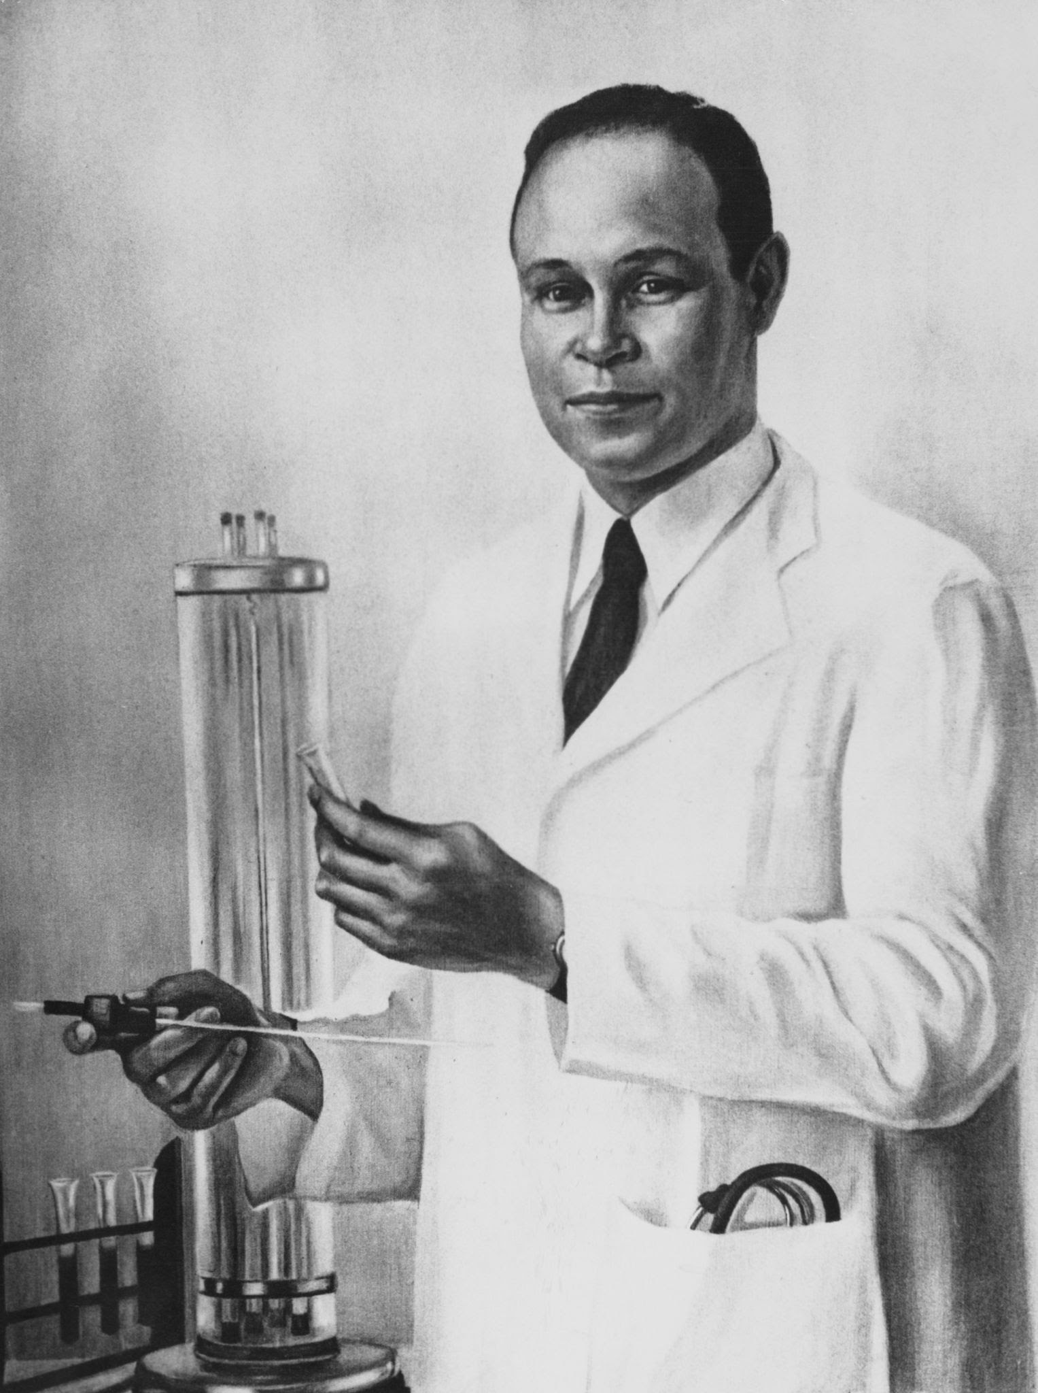

Charles Drew

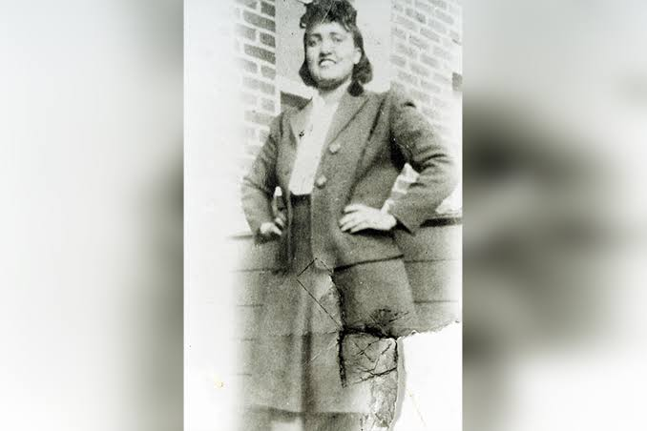

Henrietta Lacks

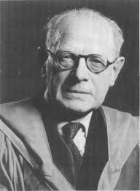

Merlyn Pryce