Book | Ideas
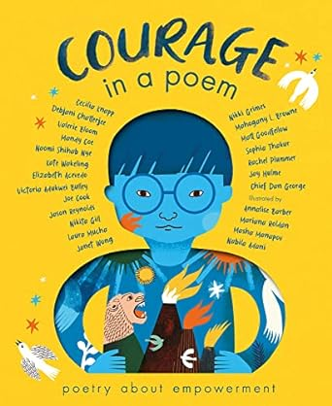 | - Read poems of your choice - what do the lines mean?  - How does the cover show 'courage' (courage)  - What words would they use to describe themself?  - Write their own poem about themself
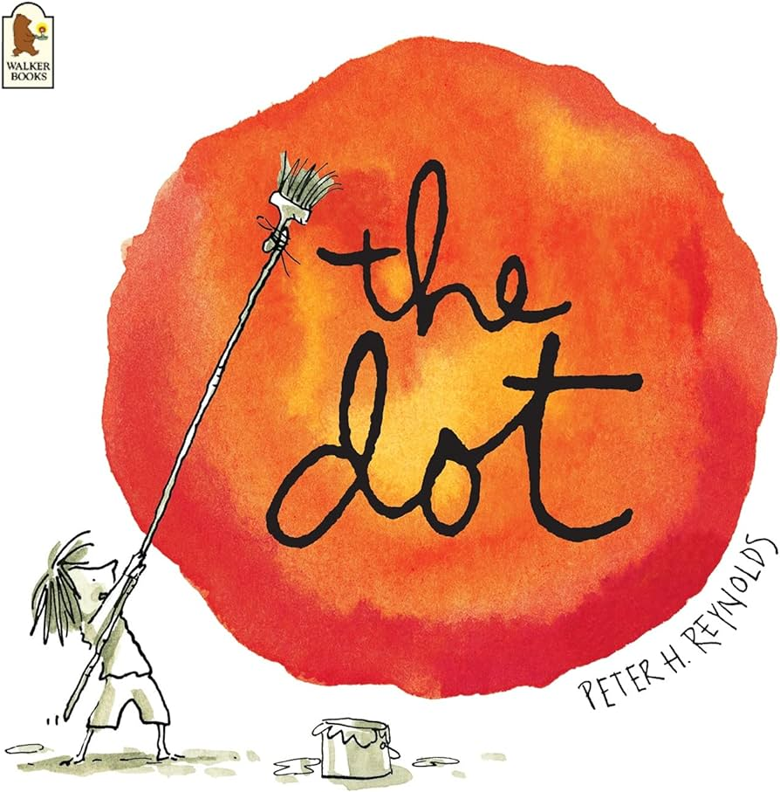 | - Link to a number of cross curricular ideas
