Notes and feedback  Where I have done well:  What I need to work on: | BOXING FITNESS  CIRCUITS RECORDING SHEET  NAME  CLASS  SCHOOL  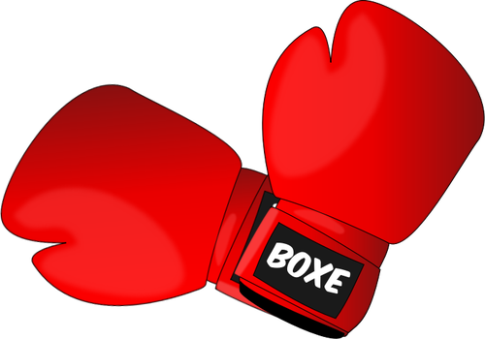

Week | Exercise 1 | 2 | 3 | 4 | 5 | 6
1

2
3
4
5

