Dal y Gwynt | Eye of the Storm – Information for Buses

Drop off/pick up point: We advise that buses drop schools off on Burrows Place, SA1 1SW close to Swansea Museum. See underlined on yellow in the map of the area below:

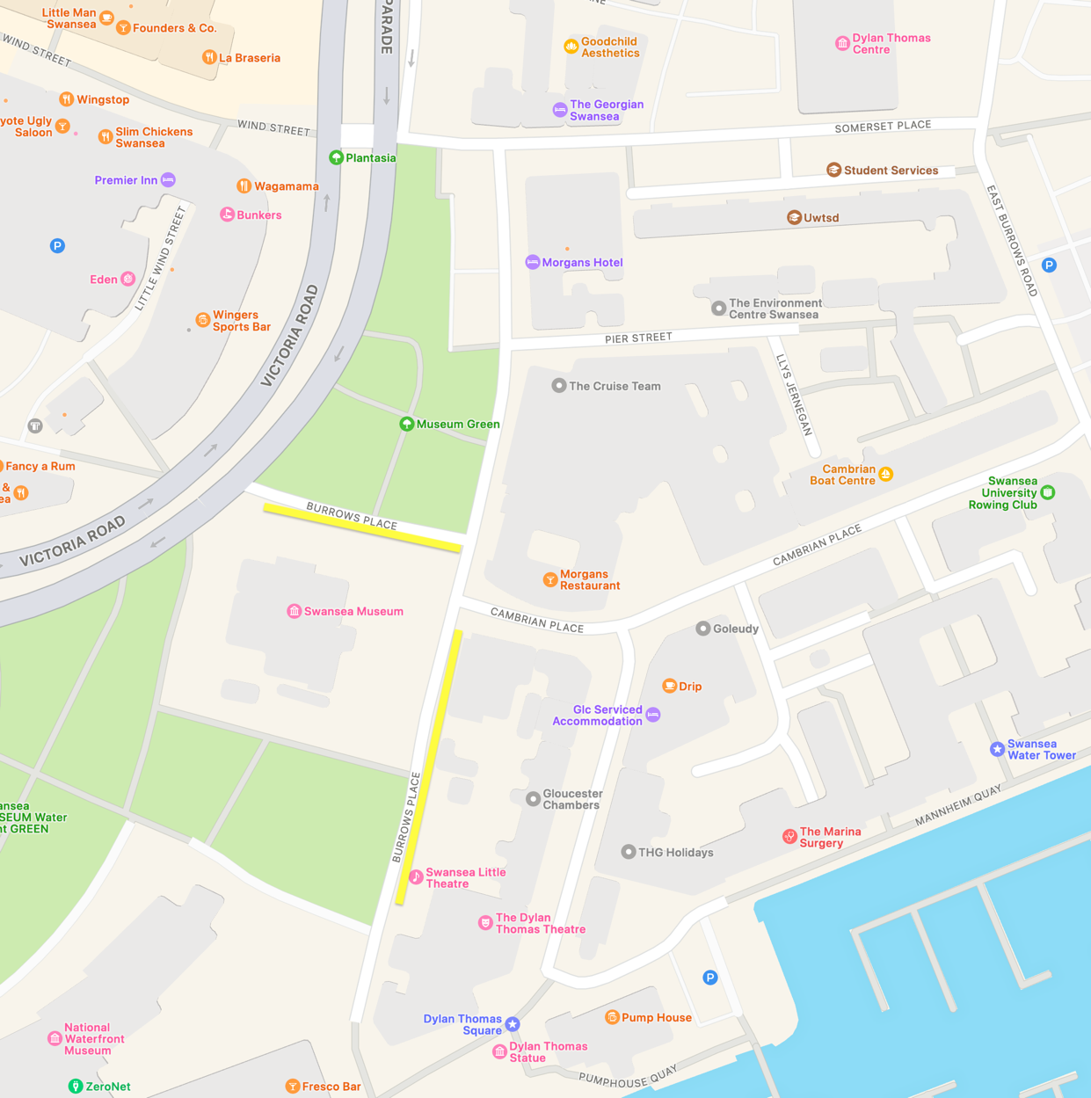

Directions: From Quay Parade/Victoria Road, turn onto Somerset Place, then right onto East Burrows Road, left onto Cambrian Place and onto Burrows Place.

You cannot park outside the Dylan Thomas Theatre.

Timings: Drop schools off at 9:45am and pick up at 2:30pm. If you are going to arrive late, or need to leave early, you must let the school know as soon as possible, as it will affect their day.

Roadworks: There are planned roadworks on Fabian Way in Jersey Marine, specifically between the Jersey Marine Junction (Amazon Roundabout) and the M4 slip road, to address persistent flooding. The works are expected to last for approximately 23 weeks and will involve lane closures with 24/7 traffic management.

If you have any questions for Theatr na nÓg please ring us on 01639 203191

Dal y Gwynt | Eye of the Storm – Gwybodaeth i Fysiau

Man gollwng/casglu: Rydym yn cynghori bod bysiau'n gollwng ysgolion yn Burrows Place, SA1 1SW ger Amgueddfa Abertawe. Gweler y ffordd wedi'i thanlinellu mewn melyn ar fap yr ardal isod:

Cyfarwyddiadau: O Quay Parade/Ffordd Victoria, trowch i Somerset Place, yna i'r dde i East Burrows Road, i'r chwith i Cambrian Place ac i Burrows Place.

Ni allwch barcio y tu allan i Theatr Dylan Thomas.

Amseroedd: Gollwng yr ysgol am 9:45yb a chasglu am 2:30yp. Os ydych chi'n mynd i gyrraedd yn hwyr, neu os oes angen i chi adael yn gynnar, rhaid i chi roi gwybod i'r ysgol cyn gynted â phosibl, gan y bydd yn effeithio ar eu diwrnod.

Gwaith ffordd: Mae gwaith ffordd wedi'i gynllunio ar Ffordd Fabian yn Jersey Marine, yn benodol rhwng Cyffordd Jersey Marine (Cylchfan Amazon) a ffordd ymuno'r M4, i fynd i'r afael â llifogydd parhaus. Disgwylir i'r gwaith bara am tua 23 wythnos a bydd yn cynnwys cau lonydd gyda rheolaeth traffig 24/7.

Os oes gennych unrhyw gwestiynau am Theatr na nÓg, ffoniwch ni ar 01639 203191

