Dal y Gwynt - Eye of the Storm

Theme Name: Weather of the mind
AOLE | STRAND | Suggested learning experiences:
Language, Literacy & Communication  Health and Wellbeing | Poster comparison | - Use the posters for ‘Eye of the Storm’ (this years and previous) to compare and discuss:  - What’s similar / different?  - Their facial expressions?  - Why are there scribbles in the background of the 2025 poster? What could this suggest?
Health and Wellbeing | Emotional check-in | You could create a whole-class check-in for your class with different weather symbols (sun, clouds, rain, storm, rainbows) where the children could express how they felt each day. You might want to label each weather with the emotion i.e Sun = happy, or leave it to be more metaphorical and creative. For example one child might put themselves on the clouds if they feel confused / tired.  This could open up lots of discussions for your class on how to support each-others, how to fill each-others buckets etc.
Health and Wellbeing | Emotions Forecast Journal | - Pupils complete a daily “weather forecast” where they could have time during different points of the day to pinpoint how they are feeling and what weather is going on in their mind.  - They could use emotional literacy to describe their feelings e.g. Today my mind feels like…” (e.g. foggy, bright, stormy, breezy) because….  - You could include space to explain why and list something that helps them in that kind of weather.  - At the end of the week, children could see how their emotions have changed throughout the week and during the day. This could help build further connections between teacher and pupil and also an emotional understanding. (a pupil could note they feel more negatively during whole-class reading as they find it more difficult or lack confidence, this could then be used to support them both emotionally and academically).
Health and Wellbeing | Journal Pages | - What's on your mind today?  - How will you have a good day today?  - Design the sky to show how you’re feeling  - What are you wishing for?
Health and Wellbeing  Expressive Arts | Weather of the mind: Art Project | - Pupils draw or paint an image of what the "weather" in their mind looks like that day.  - Use colours, shapes, and symbols instead of faces.  - Can build into a class "Emotions Forecast Gallery."  - link to creative section in Weather and Climate: Dance your emotions
Health and Wellbeing | Calm before the storm:  Regulation Stations | - Discuss: How do you feel when there’s lots going on in your mind and you can’t focus properly?  - What does your body feel like? (headache, eyes hurt, sweaty, achy, stomach hurts)  - What can you do to help in these situations?  - You could introduce the children to some regulation strategies to help them find their calm in these situations. You could try breathing techniques together, meditation, mindfulness colouring, journaling / doodling, play-doh.  - Evaluate together: What helped them the most? Why did it help them? How did their bodies feel after?
Language, Literacy & Communication  Health and Wellbeing | Mood Tracker: Emmie  Emotional Mapping | - You could use scenes from the show to track Emmie’s feelings and emotions throughout the story.  - What's affected/impacted her? How does she cope?  - How does her mood look throughout the show?  - You could use a line graph to plot her different emotions and feelings.  - 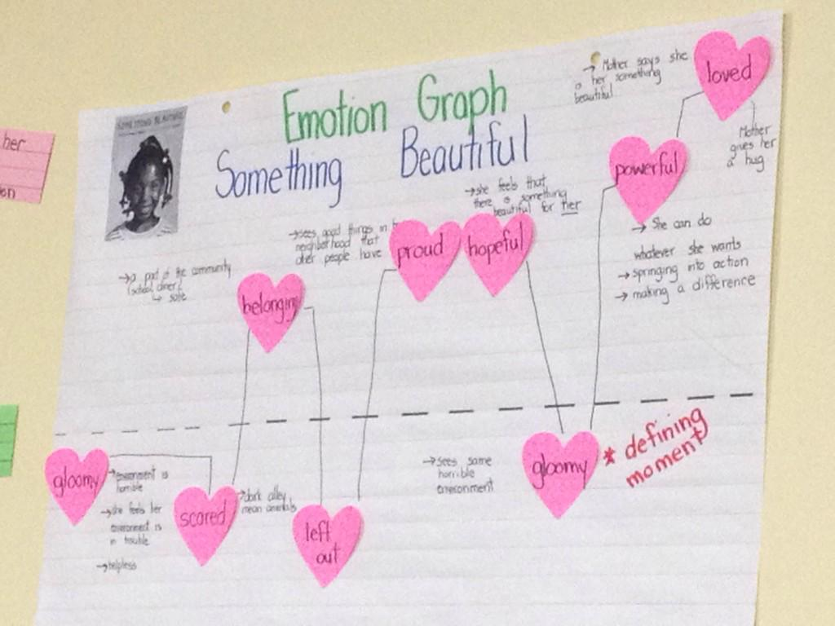 example
Literacy & Communication  Health and Wellbeing  RSE | Consequence Mapping | - Using Emmie’s story in the show, children choose 4 key events from her life (Mam being ill, sister leaving, being inspired, entering the competition) and around they note the positive and negative impact each event had on her life.  - Children could then create their own consequence map to show their life events had an impact on their lives. To further challenge them, you could encourage them to explain the impact of the consequence on them.
Literacy & Communication  Health and Wellbeing  RSE | Optional Book Pairnings | - Ruby’s Worry (Tom Percival)  - Me and My Fear (Francesca Sanna)  - The Colour Monster (Anna Llenas)  → Then discuss how characters’ “inner weather” changes and how others respond to them.

