Romjul

Theme: The power of nature and nurture
AOLE | STRAND | Suggested learning experiences:
Health and Wellbeing | looking after ourselves and our families  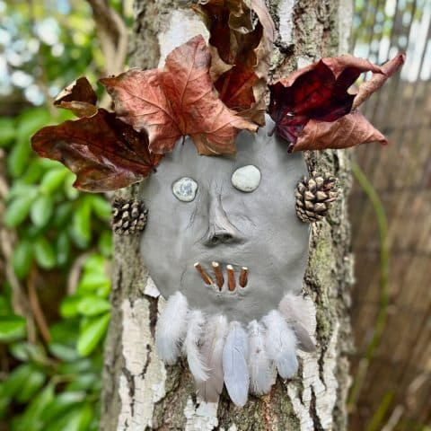 | - What is Romjul?  Romjul, a very Nordic Post-Christmas tradition  - Why do you think it is a specific time?  - Investigate the key elements? (looking after yourself mentally, physically and emotionally, exercise, being outdoors, family, good food, relaxing, setting resolutions)  - Do you think this is a good idea?  - How could we practice Romjul ourselves?  - Write a plan for yourself after Christmas  - set some resolutions  Stay inside  - in the play, the girls play Simon’s Game where you have to discover what item is missing from a given selection. Have a go at this and other older simple games.  15 fun old-fashioned activities for kids to play  Old-School Games To Play with Kids | Bright Horizons®  - make a den: put up a small tent indoors or make a den under the table, snuggle up and enjoy  Get outside:  - As a class or in the holidays, wrap up warm and get outside, challenge yourself to climb a big hill, walk in the woods, go cycling with your family, or play football on the beach.  - make a collection of natural objects  - Do a bioblitz  - make a den  - Make a dino den or a den for your puppet if you have made one  - Use hand mirrors to skywalk  - tell a story outside (it sounds different!)  - make up a story to suit your setting  - Use small balls of clay to make into woodland creatures/spirits and hide them in the woods  - Take some time to stop and look. Take a bin bag to sit on and just soak up the sounds, sights and smells around you.  - If you have one, put your phone away and give yourself a screen break.
Lands of woodland folk and mystical creatures
Mythical Beasts of Wales | Puca Printhouse
Welsh myths and folklore | Wales | National Trust
Tales from the Faerie Trails: Pennard Castle and the Verry Volk

Norse myths and legends | Learn more about Norwegian folklore | Hurtigruten UK

Both Norway and Wales have strong traditions of mythical beings from fairies to trolls. Some stories are quite brutal and may need to be edited before sharing with the children
- Investigate the Nisse, woodland and fairy folk that form the basis of both Nordic and Celtic folk tales.
- The power of respect for nature and how that can be transmitted through tales
- if you have woods nearby, then go for a walk and maybe do some of the activities above
- What is the countryside code?
- Shaun the Sheep's Complete Guide to the Countryside Code
- How can you adapt this to make sure that pupils respect your school grounds?
- Consider the results of not respecting nature. Nature is any area where things live and grow. Not just large woods, but it can be as small as a plant pot, the verge outside your house, your garden or the local football pitch, park or beach

- Link to storytelling and puppet making

Expressive art | create | - using what you know and your amazing imaginations,  - start by playing with the colours of the wood. How many different browns/greens/colours can you find? How many different colours can you make by mixing paint in different ways  - If you are very adventurous, you can take paint to the woods or use sticks, mud and crushed leaves. (messy but fun)  - Investigate textures: press leaves/bark/stones/sticks into clay and paint when dry  - draw some of the textures or use poster paint to scratch in texture or press items into it  - Draw your own woodland spirit. Consider size, special abilities, colour and camouflage  - as a class practice figure drawing in different poses  - make several sketches of different creatures  - Choose your favourite and work into a finished piece, either using paint, chalk pastels, or by supplementing with leaves, clay, sticks, etc

